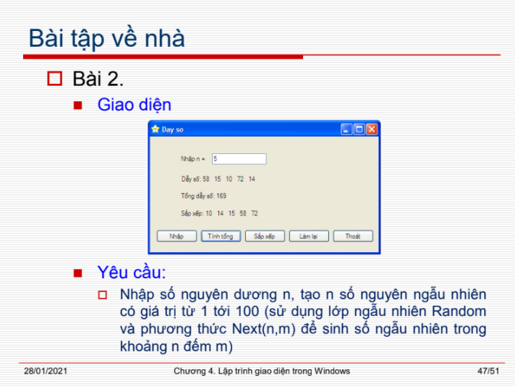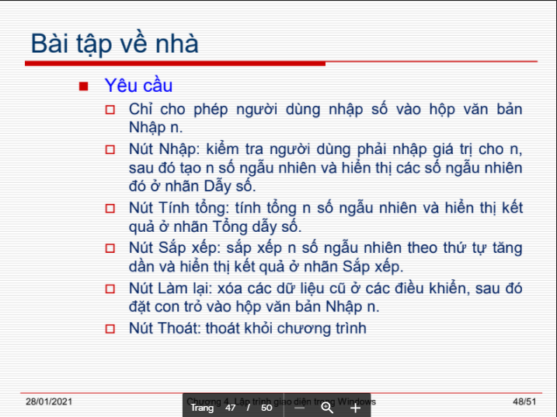

### Class DaySo

class DaySo

{

static Random random = new Random();

int[] day = new int[100];

public DaySo(Int32 n)

{

for (int i = 0; i < n; i++)

{

day[i] = random.Next(1, 100);

}

}

public string Xuat(Int32 n)

{

string s="";

for (int i = 0; i < n; i++)

{

s += " ";

s += day[i].ToString();

}

return s;

}

public string Tong(Int32 n)

{

int t = 0;

for (int i = 0; i < n; i++)

{

t += day[i];

}

return t.ToString();

}

public void SapXep(Int32 n)

{

int temp;

for (int i =0; i<n-1; i++)

{

for (int j=i+1;j<n;j++)

{

if (day[i] > day[j])

{

temp = day[i];

day[i] = day[j];

day[j] = temp;

}

}

}

}

}

### Class Form

public partial class Form1 : Form

{

DaySo mang = new DaySo(100);

public Form1()

{

InitializeComponent();

}

private void lblDaySo_TextChanged(object sender, EventArgs e)

{

}

public void new_array(int n)

{

DaySo mang = new DaySo(n);

}

public void btnNhap_Click(object sender, EventArgs e)

{

if (txtNhap.Text == "")

{

MessageBox.Show("Không được để trống n");

txtNhap.Focus();

return;

}

int n = Convert.ToInt32(txtNhap.Text);

new_array(n);

lblDaySo.Text += mang.Xuat(n);

btnNhap.Enabled = false;

}

private void txtNhap_KeyPress(object sender, KeyPressEventArgs e)

{

if ((e.KeyChar >= '0' && e.KeyChar <= '9') ||

Convert.ToInt32(e.KeyChar)==8 ||

Convert.ToInt32(e.KeyChar)==13)

e.Handled = false;

else e.Handled = true;

}

private void btnTong_Click(object sender, EventArgs e)

{

int n = Convert.ToInt32(txtNhap.Text);

lblTong.Text += mang.Tong(n);

}

private void btnSapXep_Click(object sender, EventArgs e)

{

int n = Convert.ToInt32(txtNhap.Text);

mang.SapXep(n);

lblSapXep.Text += mang.Xuat(n);

}

private void btnLamLai_Click(object sender, EventArgs e)

{

txtNhap.Clear();

btnNhap.Enabled = true;

txtNhap.Focus();

lblDaySo.Text = "Dãy số:";

lblTong.Text = "Tổng dãy số: ";

lblSapXep.Text = "Sắp xếp:";

}

private void btnThoat_Click(object sender, EventArgs e)

{

this.Close();

}

}

}